Meta Description:
Instagram Marketing allows brands to promote their business and brand to increase brand awareness, grow traffic, and boost sales.
https://drive.google.com/drive/folders/1jzesnA3DBGEvi5r6SO41C2ojVBg60BQk

What is Instagram Marketing & How to Do It in 2025?
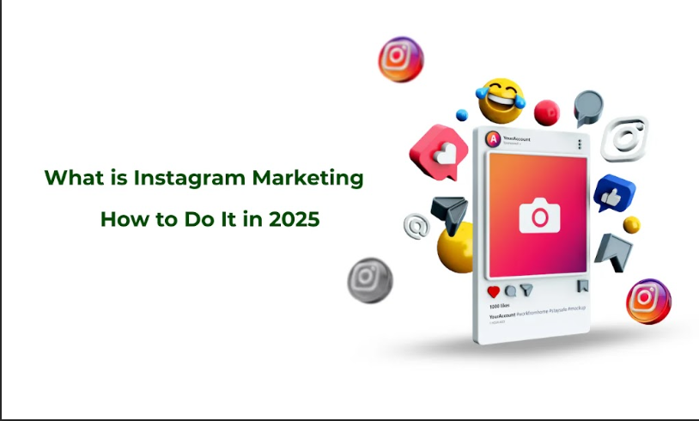
Instagram has become one of the most important platforms that can be used for the development of business in the new digital era.
Given the fact that it has over a billion active users, Instagram can indeed be used to reach as many people as possible.
The perfecting of Instagram marketing by 2025 will be a necessity for any company that seeks to vie for its market share in the incredibly competitive market.
Here in this guide, you will learn what Instagram marketing is, why it remains critical for businesses in 2025, and how your company can succeed through the use of this platform. Additionally, we will also describe its development and give you tips on how to make your brand popular on Instagram.

What is Instagram Marketing?
Instagram marketing refers to exercising, integrating, and growing a business through the use of the Instagram social platform.
It aims to create a brand story that is attractive to the target audience and help share it across the platform by leveraging all the features of Instagram for a unique branding experience, and interact with the users for brand loyalty. Here, it is best to use both types of approaches (paid & organic) to ensure maximum coverage and impact on the viewers used to visuals.

Key Components of Instagram Marketing

1. Organic Content:
- Posts: Use pictures, excellent graphic designs, animation, and effective videos in your brand messages.
- Stories: Incorporate short periods, pass the time insights into activities that are happening behind the scenes, or information that will only be relevant for a limited time.
- Reels: Use short entertaining videos to grab the users’ attention in the shortest time possible.
- IGTV: This feature allows you to provide the audience with extended video content and expand on the subject that might be of interest.

2. Paid Advertising:
- Instagram Ads: It employs paid traffic, and this can go hand in hand with the targeted traffic that can be useful from time to time.
- Sponsored Posts: Posting sponsored posts, with the help of influencers or brands, to improve the reach and reliability.

3. Influencer Collaborations:
It is also important to approach new audiences through partners with which audiences are compatible and share similar values to ensure consumer trust.

4. Community Engagement:
- Engagement with Users: Reply to the comments left by the users. This will build a strong relationship between you and your audience.
- Direct Messaging (DMs): Send your users with limited or additional individual support and information to their Instagram account.
- Hashtags: Use hashtags to make your stories and content more visible and contribute to other trending discussions.

Evolution of Instagram Marketing (2020-2025)
It is easy to identify major changes in the Instagram marketing space from the year 2020 to the year 2025 based on the changes in the Instagram algorithm, features, and consumer behavior.
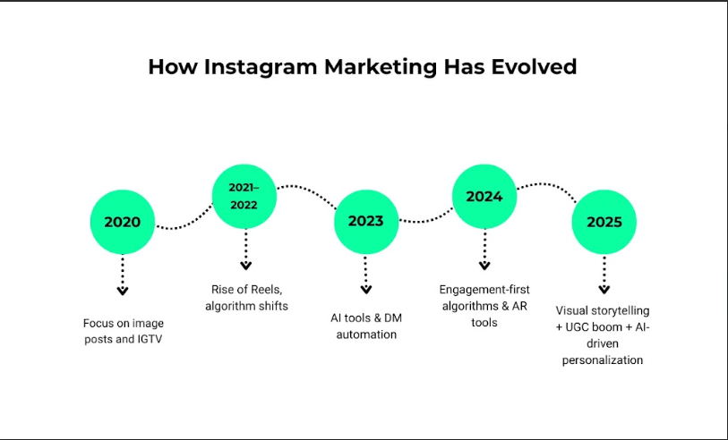
- Updates in the Algorithm: Instagram has made adjustments to the algorithms in a bid to make real and warm interactions matter even more.
- New changes: From being just a news blogging site, the platform has now become more of Reels & Stories & so on.
- User Behavior: Users are now looking for instant engagement and content that is informative or fun in some way.
- AI and Automation: AI has become prominent in Instagram marketing trends because it can be utilized in such aspects as content recommendations to customers, and sales chat credentials, among others.

Why Your Business Needs Instagram Marketing in 2025

Instagram’s User Demographics & Market Reach
According to the statistics, by 2025, Instagram will have gained millions of users belonging to different categories, which is likely to turn Instagram into an indispensable tool for getting in touch with the desired audience. Its user demographics include:
- Gen Z: Individuals born between 1997 and 2012 are referred to as Gen Z. This is the primary platform they are most attached to.
- Geographical Coverage: This platform can reach out to a wide client base by targeting International youth.
- Time Spent: Users stay on the platform for a long time because it creates higher chances of engagement and overposting.
Here is what can work for your business on Instagram that helps you streamline your business operations:
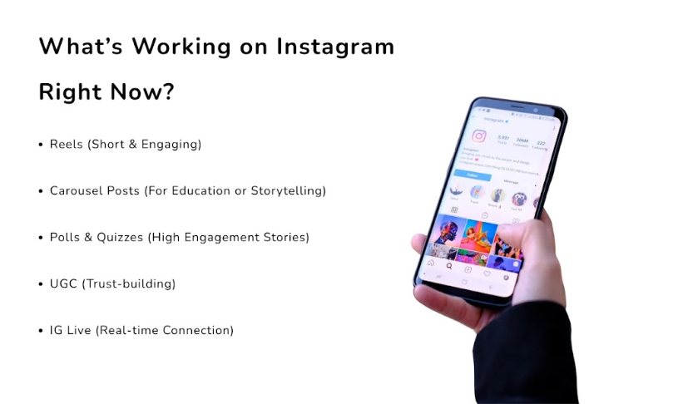

Benefits of Instagram Marketing:

1. Brand Awareness:
It has become an effective platform for brands to develop visually appealing images and videos that would attract attention and make a brand memorable.

2. Lead Generation & Sales
Through Instagram advertising, you can attract clients and also convince them to purchase products from your business.

3. Customer Engagement
Instagram places brands directly in touch with customers. This way, brands can easily get feedback as well as respond to queries.

4. Competitive Advantage
To win and remain relevant in the digital space, it is important for companies to use the features of the platform to engage the target market and, in the process, stand out from rivals.

Instagram vs. Other Social Media Platforms
This is unlike other platforms such as Facebook, Twitter, and LinkedIn, which possess their own benefits. Here are the major benefits of this platform that differentiate it from the rest of the platforms.
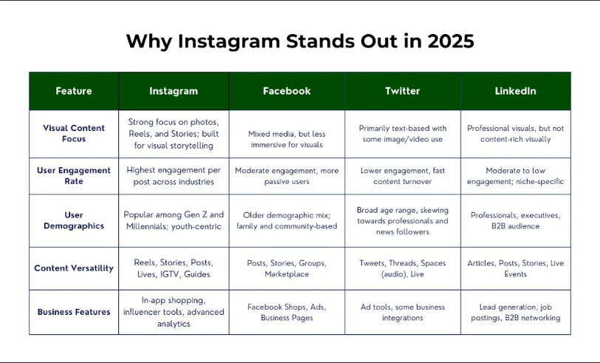
- Uniqueness: On the matter of uniqueness, it is apparent that Instagram enhances the visibility of brands that have a focus on the visual.
- Activity Rates: You can observe the one-way and two-way activity rates through the use of this platform.
- Business suitability: Instagram remains advantageous in terms of its business capabilities since it supports a number of content types, such as Reels, IGTV, and so on.

How to Set Up Instagram for Marketing?
Like many other social media platforms, Instagram also has a serious side and can be regarded as a marketing tool for business development and promotion. Here is how you can set up your Instagram for marketing:
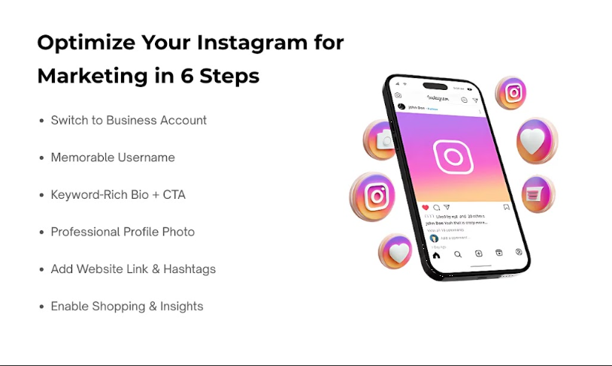

Create a Compelling Profile:
- Choosing a memorable username: When making a selection, the username should be easy to remember. Also, ensure you add references to the brand and incorporate all major keywords.
- Write a Compelling Bio: Be detailed but also brief. Emphasize what your brand provides and ensure you have a footer that contains the CTA, a website link, and a unique hashtag.
- Craft a Better First Impression: The picture that the audience will first see on the profile must be clear and something that gives the audience an idea of what the profile is all about, for instance, a logo.
- Choose a Good Background on the Profile Photo: This may be the URL, brand image, or an abbreviated brand description.

Utilize Instagram's Business Features
- Convert Your Account to Business: Measure the effectiveness of your posts through the upgrade of your account to a business account.
- Hashtag Shopping: If active, use shopping features that will enable users to make a purchase on your Instagram.
- Utilize Instastats: This will help in tracking the engagement level of your account with that of the followers and compare it to identify your brand's strengths and weaknesses in marketing strategy.

Build a Strong Content Foundation
- Use Quality Images & Videos: It is also advisable to use quality images and videos for the purpose of posting, as they are used in professional formats. When it comes to Instagram, quality wins over quantity every time because it is a visual social network.
- Make a Content Calendar: Developing a content calendar is wise because it helps in organizing your posts. Regular and proper posting is the key to winning the followers’ trust.
- Try Various Post Formats: The majority of influencers should adopt post formats such as posts, stories, reels, IGTV, and live sessions to keep their audiences entertained.

Engage with Your Audience
- Respond to Comments and Messages: Getting involved with the content and being quick to note down comments and messages requires being active. This will also help in engagement through community building and trust.
- Polls and Questions in Stories: These two enhance the interaction of people and also the feedback received.
- Hosting giveaways and Contests: Host contests with a view to worker extra followers.

How to Build Your Instagram Marketing Strategy for 2025?
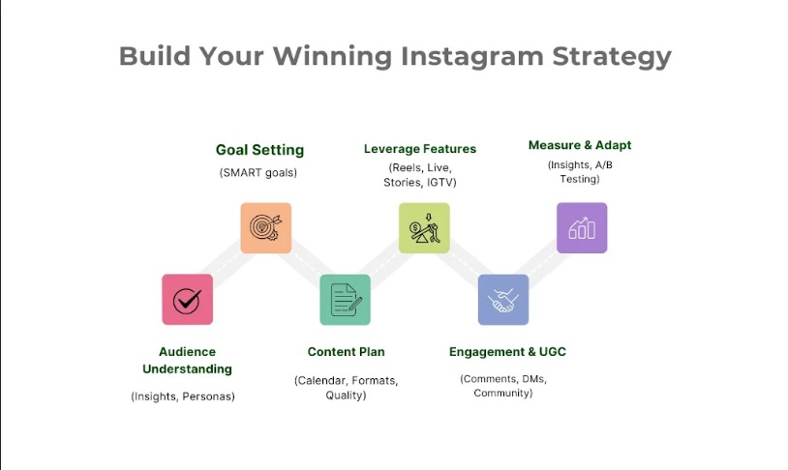

Understand Your Audience
- Market Analysis: Establish the target audience and their characteristics, preferences, and habits. Use insights available on Instagram to make your findings on the analysis.
- Develop Targeted Audience Segments: Writing for deaf people requires writing for targeted customers. The best way to do this comprehensively is to create target audience personas.
- Follow New Trends: You need to be up to date with the latest trends and hashtags in a bid to reach out to a larger segment of audiences

Define Clear Goals
- SMART: Will refer to Specific, Measurable, Achievable, Relevant, and Time-bound goals.
- Direction on Achievements: It is crucial to identify goals such as building brand visibility or maybe making sales to cater to the overall goal that is aimed at by a certain brand.
- Monitor and Evaluation: Always analyze your goals and modify them according to the next performance.

Develop a Content Strategy
It would be more productive to work on quality content that entices the audience, causes them to think, or even provides some form of entertainment.
- Tap into the power of UGC: You should also repost content created by your followers that is related to your brand activity and published on their profiles.
- A/B Test: This is very important in social media advertising, as there are so many types of content that you can create.

Leverage Instagram's Features
- Instagram Stories: It is the feature that enables the sharing of photos and videos that disappear after 24 hours. Stories best suit as Live, behind-the-scenes content, daily updates, and special offers.
- Follow the Reels Algorithm: Produce and share multiple short videos to take advantage of the algorithm.
- Use IGTV for Long-form videos: IGTV can be used for detailed content that covers tutorials, interviews, or product reviews.
- Go Live: Establish an engagement with the audience to broadcast messages in real time. This can be effective for holding talks, information presentations, Q&A sessions, or even when you are going to introduce new products to the market.

Collaborate and Build a Network
- Join with other Sellers: Work with the influencers who have similar ideas and values to your brand.
- Partner with Competitors: You should extend cooperation with other brands that are similar to your brand by exchanging the content they publish.
- Engage in Niche Community: You should involve yourself in groups and discussions for the best exposure.

Monitor and Optimize Your Strategy
- Track Impacts: From the social media marketing strategies, you can measure aspects like reach, followers, reaction rates, and conversion rates.
- Analyze Performance: This shows areas that are being effective and those that are not by utilizing data analysis techniques. So, you can adjust your strategy accordingly.
- Stay Updated: More often than not, changes occur in the functionality of the application, so always be ready to adapt.

Embrace Emerging Technologies
- Engage with Augmented Reality (AR) filters: Use filters that you would have created in a manner to share with the audience a new experience.
- Embrace the use of Chatbots: Adopting the future is a new way to reach out to customers.
- Adapt to Newer Things: As new additions are being incorporated into the application by Instagram, try to be at the forefront to use them.

Top Tips for Instagram Marketing Success in 2025:
By 2025, Instagram will remain one of the top platforms of digital marketing. This is mainly due to the flexibility in its interface and a wide range of users, this platform is the top choice of brands to succeed in no time. Here is how you can achieve success by running a successful Instagram marketing strategy.

Embrace Visual Storytelling:
Instagram is fundamentally a picture-sharing application. To engage your audience, it is important to narrate through compelling media. Any product linked to a story or an emotion will be more appealing and satisfying in terms of image or video quality. To draw the audience’s attention, use bright colors, schematics, minimalism in the layout, and engaging storytelling.

Leverage Instagram Reels
Reels in the Instagram application will become even more significant due to the growth of the popularity of short-form content. These are short, 6-second videos that can be quite entertaining to your audience in the course of viewing them.

Prioritize Engagement
Engagement can be considered the most important aspect of the Instagram success story for a business. To enhance engagement with the followers, you need to reply to comments on posts, like the posts, as well as the followers’ posts.
Instagram is particularly helpful in engaging the audience with the use of Instagram Stories options, such as asking questions, using polls, etc. Personal interaction enables a business to be more visible and helps to cultivate the brand relationship.

Utilize User-Generated Content:
This type of content gives credibility to the products and services sold online because it comes from loyal customers. It often involves sharing user content to your Stories or feed. Not only does it reinforce your brand, but it also constructs an environment of a community among the followers.

Optimize for Mobile:
Instagram is a mobile application, so make sure all your content is adapted for mobile. This means high-quality videos, clear font, and seamless navigation at every level. By thinking in this way, you can ensure that your content shines when viewed on customers’ small screens.

Develop a Consistent Posting Schedule:
Another effective strategy is to keep the posting schedule consistent by creating a content calendar. Among the things that should not be compromised in business are deadlines, and these should be achieved by using the tools to schedule the work during busy days. It also enables you to keep your audience hooked while on the other side, assisting in increasing user base growth steadily.

Focus on Hashtag Strategy:
Hashtags are crucial for discoverability. It is necessary to use both the most popular and not widely used hashtags to connect with the topic of your post. By exploring trending hashtags, you can create a branded hashtag for your campaigns.

Invest in Instagram Ads:
It is good to understand that Instagram ads are helpful in increasing visibility and selecting target categories. To choose the most effective strategy, your advertisement should be colorful, and A/B testing carried out. The advertising tools available on Instagram enable marketers to earn higher ROI by giving them an opportunity to reach their target market.

Analyze and Adapt:
Instagram is a highly measurable platform, so you should utilize it effectively. By using the Insights feature available on Instagram, the performance can easily be tracked. For analysis, you can consider factors like engagement rates, the number of followers reached, as well as the rate of growth. As every plan is unique and requires a unique way of handling, change your strategy depending on the strategy that favors you most. So, make sure you continue to sharpen your strategies and tactics to have a better assurance of long-term profitability.

Most Popular Types of Content on Instagram in 2025
As time passes, some of the main forms of content will always remain relevant in the application. Here are the most popular content types on Instagram in 2025.

Reels and Short-Form Videos
This will include sharing short videos through the use of videos, pictures, and text. Short videos and Reels on Instagram still generate much attention. Due to users’ dwindling attention span, they seem to be very brief and innovative. You can use this for product demonstration, showing behind-the-scenes moments of your products, or relatable, humorous clips.

Build Interactive Content
Polls, quizzes, and Q&A sessions in Instagram Stories are the most relevant interactive content. This type of content motivates your audiences to interact with your content by enhancing the level of interaction to develop insights into what they like. It’s a strong instrument, with which people can closer on the emotional level.

Effective Tools for Instagram Marketing: Free & Paid
If you want to benefit from the social marketing strategy of Instagram, it is necessary to have the right tools. Here we present you with a list of free and commercial tools that may prove useful in this task.

Free Instagram Marketing Tools

Canva:
You should find Canva suitable for your Instagram post designs because it is easy to use for creating good-looking post designs. Some of its features, which include its library of ready-made templates and design items, are specifically helpful in the creation of professional-looking graphics even with limited graphic design skills.

Instagram Insights:
Instagram Insights is a built-in tool that will give you information about the account within certain periods of time. It provides information about the audience followers, post audience, and insight, which is effective when developing strategies.

Hootsuite:
In Hoost, you can update various accounts on social media platforms simultaneously on one platform. The free service allows setting up a post in advance and controlling mentions that can help maintain the activity level.

Paid Instagram Marketing Tools

Later:
Later is a mobile application officially endorsed as an Instagram scheduling tool that enables its users to schedule posts. It has the feature of a visual planner that allows you to pre-plan your feed and get a good-looking grid.

Iconosquare:
It has features that will give you the analysis of your own Instagram and the competitiveness of your rivals, too.

Tailwind:
Tailwind is also an effective tool that can be used for marketing on Instagram. It has some features that include scheduling, the ability to track hashtags, and engagement statistics. The premium version opens more possibilities and offers more detailed analytics for those who want to improve their approach.

Agorapulse:
It is the best social media management software that offers all-around social media management. Some of the features include post-scheduling, team management, and analytics with multiple networks, namely IG.

Conclusion
As everyone now fully realizes, Instagram is a constantly developing platform, and unpredictable circumstances are happening frequently for marketing strategies. Therefore, it is possible to utilize visual language, create short and attention-grabbing content, as well as use helpful tools to develop a successful Instagram account.
At Three Angle Marketing, we will assist you in making the most of your potential on Instagram. No matter if you are new to it or if you are looking to improve the process, we have the knowledge that will help you through it.

